Department of Veterans Health Administration

Office of Informatics and Analytics

Innovation Program

OneVA Pharmacy

Integration Interface Control Document (ICD)



Version 1.0

March 2016

Revision History

The revision history cycle begins with the initial release of the OneVA Pharmacy Integration Interface Control Document (ICD). Each time the document is updated, the Title Page lists the new version number and date, and entries are made to the revision history table, which includes the description of the changes made.

Table : Revision History Table

| Date | Version | Description | Author |
| --- | --- | --- | --- |
| 03/08/2016 | 0.1 | Initial Draft | Tony Burleson |
| 03/09/2016 | 0.2 | Technical Editing | Kathy Coupland |
| 03/09/2016 | 0.3 | Review and update | Tony Burleson |
| 03/10/2016 | 1.0 | Technical Editing, baseline, and updates for Local/Dispensing & Remote/Originating | Kathy Coupland |

Table of Contents

1. Introduction 1

1.1. Scope 1

1.2. Purpose 1

1.3. Interface Design Constraint Specifications 2

2. Reference Information 2

3. Use Cases 3

3.1. Use Case: View Orders 3

3.2. Use Case: Dispense Remote Order 5

4. Interface Definition 8

4.1. HDR/CDS Request 8

4.2. HDR/CDS Response 9

4.3. Date Formats 14

5. HL7 Messages 14

5.1. QBP^Q13 15

5.2. RTB^K13 15

5.3. RDS^O13 16

5.4. RRD^O14 16

Table of Figures

Figure 1: Component Diagram of System and Protocols 2

Figure 2: Sequence of Events and Message Types for View Orders Use Case 3

Figure 3: Sequence Diagram of Dispensing Medications & Updating the Remote/Originating VistA Instance 5

Figure 4: Example the VistA Site ID to FQDN Cross Refeence Mapping 7

Figure 5: HDR/CDS Endpoint Diagram with Method Call and Parameters 8

Figure 6: SOAP Template to make an HDR/CDR Request 9

Figure 7: Simulated HDR/CDS Response Displaying 2 RXs for one Patient 10

Figure 8: HDR/CDS Pharmacy.xsd for a Single OutpaitentMedicationPromise 11

Figure 9: Sample Mapping of OutpatientMedicationPromise with a row in the RTB^K13HL7 Message 13

Figure 10: Medication Instructions Structure 13

Table of Tables

Table 1: Revision History Table i

Table 2: VistA Port Numbers for Deployment Tier 7

Table 3: Variables and Descriptions 9

Table 4: HDR/CDS Data Elements and Description 11

Table 5: Date Formats 14

Table 6: HL7 Message Flow 14

Table 7: PID Segment Data Elements and Descriptions 15

# Introduction

Leadership at the Department of Veterans Affairs (VA) initiated the OneVA Pharmacy project to enhance and integrate the OneVA Pharmacy prototype into Veterans Health Information Systems and Technology Architecture (VistA). The OneVA Pharmacy module will provide the Department of Veterans Health Administration (VHA) the capability to allow Veterans travelling across the United States to refill their active VA prescription at any VA Pharmacy regardless of where the prescription originating. The module expands available pharmacy information in VistA to pharmacists providing direct access to any active and refillable prescription from any VA Healthcare System. The OneVA Pharmacy project modifies the existing prototype software to expand its current capability and includes the development of documentation to support a national rollout in 2016.

The OneVA Pharmacy module and this implementation provides a foundation to build and extend new capabilities to the Veteran, who are better served by integrating virtual care into pharmacies, using technology to close the gap between the previous quality of information, and the Veteran's level of engagement. A well-designed OneVA Pharmacy builds upon the history of the VHA, and advances in modern technology to allow Veterans to take a more active role in their own health care.

## Scope

The overall OneVA Pharmacy system design is partitioned into two main components. They are:

1. VistA Server
2. Enterprise Messaging Infrastructure (eMI) Enterprise Service Bus (ESB) (eMI)

The VistA Server is the user interface where a pharmacist uses the “Patient Prescription Processing [PSO LM BACKDOOR ORDERS]” menu option to query for and refill, patient’s active and refillable prescriptions; from local/dispensing and remote/originating sites. The eMI receives requests from VistA to query the Health Data Repository/Clinical Data Service (HDR/CDS) for a patient’s active and refillable remote prescriptions. The VistA server and the eMI communicate with each other using Health Level 7 (HL7) v2.5.1 over Minimal Layer Protocol (MLLP). Communication to the HDR/CDS will also be via SOAP web services.

The scope of the OneVA Pharmacy Integration Interface Control Document (ICD) is limited to the touch points between the VistA local/dispensing and remote/originating instances and between the VistA local/dispensing instance and the HDR/CDS repository. The ICD is intended for all party’s requirement in such information, including software developers, system designers, and testers responsible for implementing the interface.

## Purpose

The purpose of the OneVA Pharmacy ICD is to present the software interface specifications that will support the OneVA Pharmacy system integration with the VA eMI. It will define the high level design for the OneVA Pharmacy project objectives. It describes system components, defines the message structure and protocols which govern the interchange of data, identifies the web service call, details the transformation specification, and identifies the communication paths along which the data is expected to flow for a successful of the integration of OneVA Pharmacy into the eMI.

## Interface Design Constraint Specifications

Version 2.5.1 of the HL7 specification will be used for the message format. The SOAP message versions are directed by the HDR/CDSs endpoint requirements. The following image shows the local/dispensing VistA instance query to the HDR/CDS and the message communication flow from the local/dispensing VistA instance to one or more remote VistA systems.

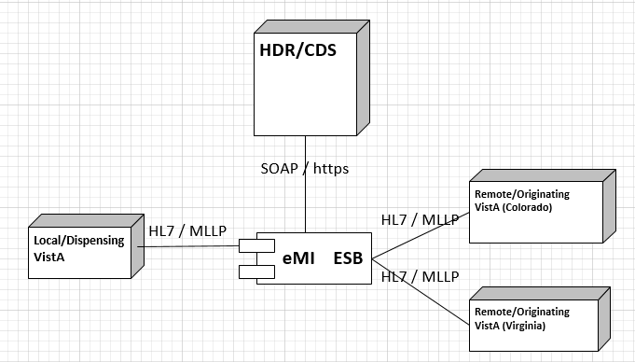

Figure : Component Diagram of System and Protocols

# Reference Information

The following URLs are links to the repository of the pre-development environment code and the source for mapping and transformation.

* [GitHub Repository](https://github.com/VHAINNOVATIONS/One-VA-Pharmacy/tree/master)
* Web Service Definition Language LINK [WSDL](https://github.com/VHAINNOVATIONS/One-VA-Pharmacy/blob/master/oneva/HDRClientWsdl/wsdl/cds-service.wsdl)
* XML Schema Definition LINK [XSD](https://github.com/VHAINNOVATIONS/One-VA-Pharmacy/tree/master/oneva/HDRClientWsdl/xsd)
* [HDR/CDS Request XML LINK](https://github.com/VHAINNOVATIONS/One-VA-Pharmacy/blob/master/oneva/OneVAProjectJava/conf/hdr-request.xml)

# Use Cases

## Use Case: View Orders

The ‘View Orders’ Use Case describes the process for users to view all of a patient’s active prescription orders. This process allows a user to view prescription order information in one place whether the order originated from a local/dispensing or remote/originating VistA instance.

When the Pharmacist enters a request to display the Medication Profile screen from a local/dispensing VistA instance, the QBP^Q13 HL7 query message is sent to eMI. The eMI will harvest the necessary information to send a SOAP request to the HDR/CDS repository for the patient’s prescriptions. The SOAP response is transformed into a RTB^K13 HL7 message that contains the patient’s prescription data. The patient’s prescription data is returned to the local/dispensing VistA instance and displayed on the Medication Profile screen.

The following image displays the sequent of events and message types for the View Orders Use Case.

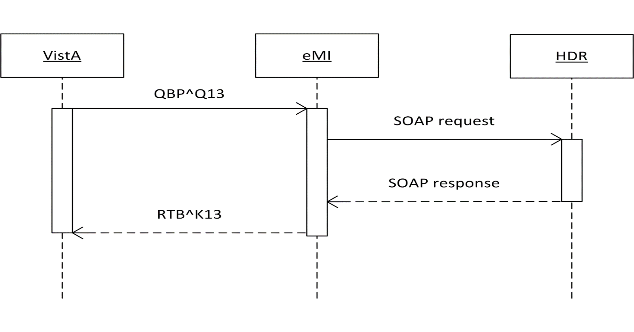

Figure : Sequence of Events and Message Types for View Orders Use Case

Actors

* User (Provider, Pharmacist, etc.)
* Local/Dispensing VistA instance
* HDR/CDS
* VA eMI ESB (proxy to remote/originating VistAs)

Pre-Conditions

* Patient must have an ICN
* User has accessed the Pharmacy Benefits Manager (PBM) Manager Menu [PSU PBM MANAGER MENU] (no separate Security Keys required)

Flow of Events

1. User enters the Medication Profile screen.
2. The local/dispensing VistA instance will retrieve the local/host prescriptions.
3. The local/dispensing VistA instance will send a request via the VA eMI ESB to the HDR/CDS with the patient identifiers to retrieve the prescriptions with a status of ‘**Suspended’**, ‘**Active’**, or ‘**Hold’** from all previous treatment facilities ***excluding*** local facility. [RSD 2.6.1.4]
4. The local/dispensing VistA instance will display all prescriptions. [RSD 2.6.1.1]

Exceptions

* 3a. VA eMI ESB is not accessible.
* 3b. HDR/CDS is not accessible.

System Message

* 1a. “Please wait. Checking for remote prescriptions. This may take a moment…” [RSD 2.6.1.2]
* 1b. Eligibility: RX PATIENT STATUS: OPT NSC//
* 3a. “The system is down or not responding. Could not query remote prescriptions. Press RETURN to continue.” [RSD 2.6.1.7]

## Use Case: Dispense Remote Order

The ‘Dispense Remote Order’ Use Case describes the process for users to dispense a remote order. Once the View Order Use Case has executed successfully, the Pharmacist, using the local/dispensing VistA instance, can select a prescription from the Medication Profile screen that originating in another VistA instance, other than the local/dispensing VistA instance, and dispense. The local/dispensing VistA will send an RDS^O13 HL7 message to the eMI. The eMI will receive the request, determine the destination facility, then forward the message to the remote/originating VistA instance. The remote/originating VistA instance will process the message and return a response message to the eMI, which will communicate back to the local/dispensing VistA, displaying the completion of the transaction to the Pharmacist on the screen.

The following image displays the sequence of events and message types for the Dispense Remote Order Use Case.

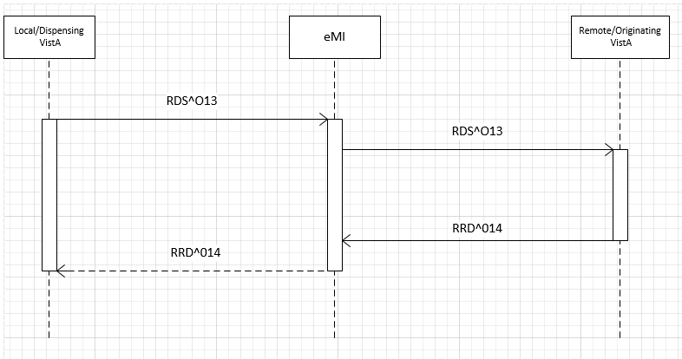

Figure : Sequence Diagram of Dispensing Medications & Updating the Remote/Originating VistA Instance

Actors

* User (Provider, Pharmacist, etc.)
* Local/dispensing VistA Instance
* VA eMI ESB
* Remote/originating VistA Instance

Pre-Conditions

* Patient must have an ICN.
* Local/dispensing VistA instance has the required amount of prescribed medication inventory on-hand.
* User has accessed the PBM Manager Menu [PSU PBM MANAGER MENU] (no separate Security Keys required

Flow of Events

1. User selects a remote prescription and RF (Refill) from the Medication Profile screen.
2. The local/dispensing VistA instance will send a refill order request to the VAeMI ESB.
3. The VA eMI ESB will route the refill order request to remote/originating VistA instance.
4. The remote/originating VistA will conduct order checks.
   1. The remote/originating VistA will update the prescription order; decrement refills, without affecting inventory.
5. The local/dispensing VistA instance will dispense medication.

Alternate Flow

1. User selects a non-local (originated on another VistA instance) prescription and PF (Partial fill) from the Medication Profile screen.
2. The local/dispensing VistA instance will send a partial fill order request to the VAeMI ESB.
3. The VAeMI ESB will send partial fill order request to remote/originating VistA instance.
4. The remote/originating VistA will conduct order checks.
5. The remote/originating VistA will update the prescription order; update partial fill date without affecting inventory.
6. The local/dispensing VistA instance will dispense medication.

Exceptions

* 2a. VAeMI ESB is not accessible.
* 3a. The remote/originating VistA is not accessible
* 3b. The prescription is a controlled substance
* 4a. The remote/originating VistA instance fails the order.

System Message

* 1a. Please wait. Checking for remote prescriptions. This may take a moment…
* 1b. Eligibility: RX PATIENT STATUS: OPT NSC//
* 2a, 3a. The system is down or not responding. Could not query remote prescriptions. Press RETURN to continue.
* 3b. Cannot refill Rx# xxxxxxx. This is a controlled substance.
* 4a. " *** Drug is inactive for Rx # "_$P(PSOREF("RX0"),"^")_" cannot be refilled ***"

; "Can't refill Rx # "_$P(PSOREF("RX0"),"^")_", it is not for this patient."; "Cannot refill, Rx is discontinued or expired. Later Rx may exist."; "Can't refill, no refills remaining."; "This drug has been changed, No refills allowed"

### VistA Site ID and Fully Qualified Domain Name

The HL7 messages contains the ‘Site ID’ for the destination VistA it needs to be routed to for processing the order. In order to communicate to the remote/originating VistA instance, the communication will require the use of a machine’s fully qualified domain name (FQDN). The FQDN will need to be resolved using the ‘Site ID’. At this time, the OneVA Pharmacy team is not aware of the source of the owner but assumes there is a VistA administrator who would be able to provide the VA eMI team with a list of all the VistA instances and a cross reference of the ‘Site ID;’ to the ‘FQDN’.

The OneVA Pharmacy code delivered to the VA eMI team uses a CSV file with ‘Site ID’ and FQDN mapping as a placeholder.

The following image is a sample of the format that provides a cross reference to a VistA ‘Site ID’ to a FQDN.

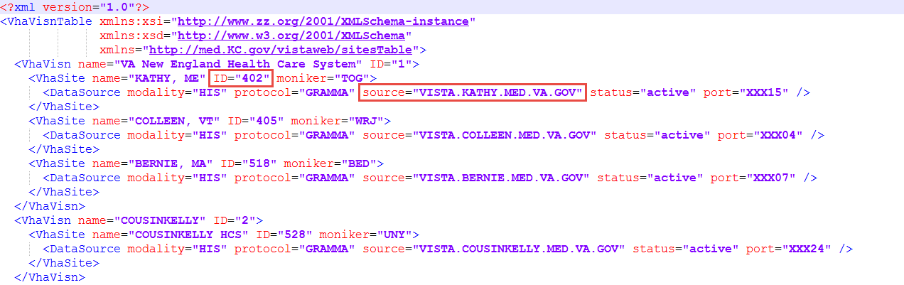

Figure : Example the VistA Site ID to FQDN Cross Reference Mapping

In the example, the highlighted ‘Site ID’ ‘402’ has the FQDN value of vista.kathy.med.va.gov. The ports in the xml file are mocked data ports and not the ports OneVA pharmacy will use in order to pass messages. The current assumption is that all the VistA instances will have to open a specific port for OneVA Pharmacy.

The following table lists the deployment tier and the expected port number the VistA instances are expected to be listening on for communication.

Table : VistA Port Numbers for Deployment Tier

| TIER | VistA Outgoing PORT | VistA Incoming PORT |
| --- | --- | --- |
| Dev | TBD | TBD |
| Test | TBD | TBD |
| Prod | TBD | TBD |

# Interface Definition

## HDR/CDS Request

The following image displays the HDR/CDS endpoint, the method, and parameters. The method being incorporate within the OneVA Pharmacy projects it the ‘readClinicalDate1’ method.

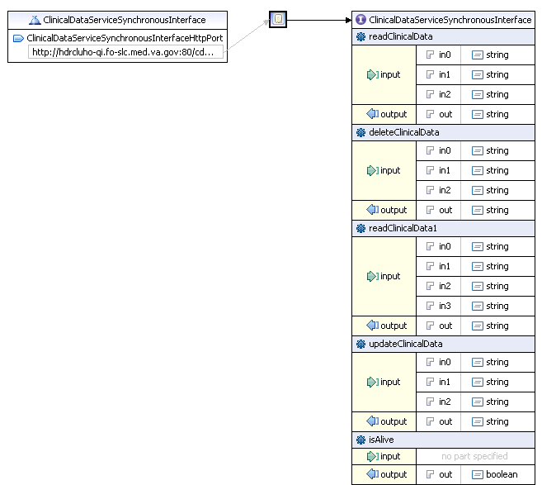

Figure : HDR/CDS Endpoint Diagram with Method Call and Parameters

### Transformation

The following image displays a SOAP template and highlights the code that harvests the patient ICN from the QBP^Q13 HL7 v2.5 message and will be used in the OneVA Pharmacy process.

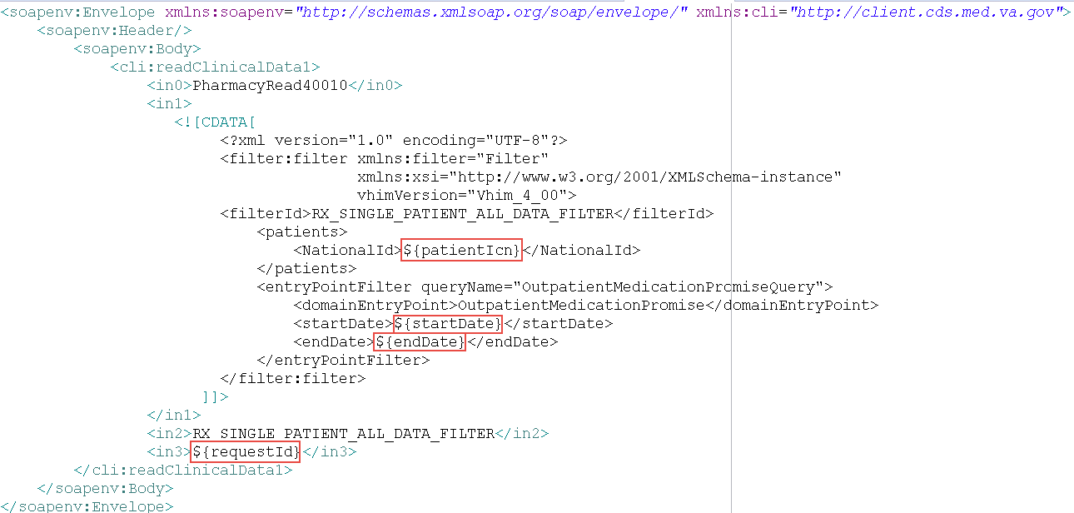

Figure : SOAP Template to make an HDR/CDR Request

The following table lists the SOAP variables and descriptions.

Table : Variables and Descriptions

| Variable | Variable Description |
| --- | --- |
| patientIcn | This is the national patient ID that exists across all VistA systems |
| startDate | The beginning date in which to retrieve a patient’s records. Since all records are required, the startDate is hard-coded to January 1st, 1900 |
| endDate | The end date to use. It will always be the current date. |
| requestId | A client-supplied request id in order to correlate requests and responses for potentially asynchronous calls |

## HDR/CDS Response

### Business Rules

The OneVA Pharmacy integration with the eMI will include the following business rules when processing the HDR/CDS response:

* Filter out any prescriptions where the site ID is the same site ID as the originating QBP^Q13 message (i.e. the calling VistA instance) [RSD 2.6.1.1]
* No grouping or sorting is needed in eMI; the calling VistA will change the order of the prescriptions as needed [RSD 2.6.1.5]

### Transformation

The OneVA Pharmacy integration with the eMI will include a transformation process. The HDR/CDS response is an array of OutpatientMedicationPromise objects. The following image shows a simulated SOAP response with two prescriptions. One OutpatientMedicationPromise is equal to one prescription.

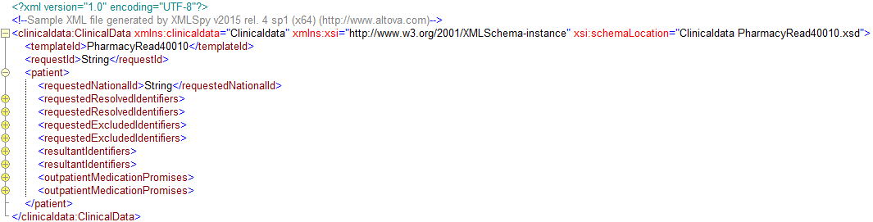

Figure : Simulated HDR/CDS Response Displaying 2 RXs for one Patient

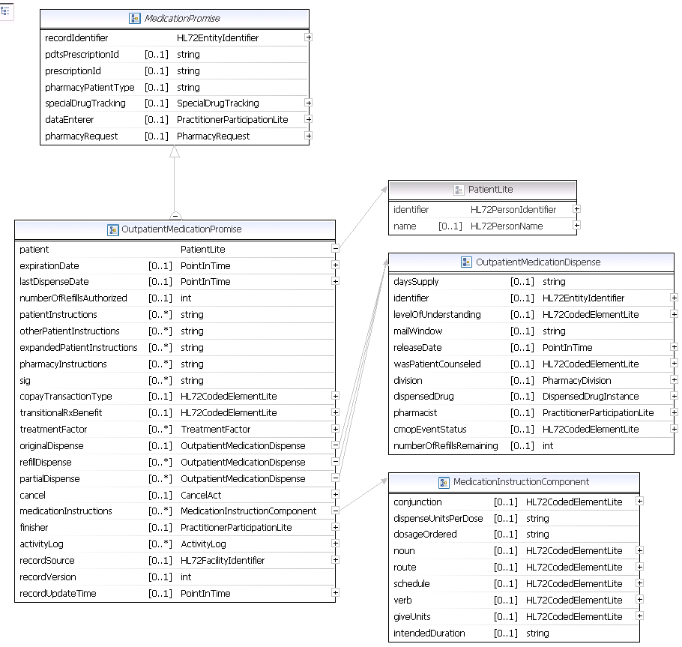

Figure : HDR/CDS Pharmacy.xsd for a Single OutpaitentMedicationPromise

The following is a sample RTB^K13 HL7 message that is transformed from the HDR/CDS SOAP response:

RDF|12|Site Number~Rx Number~Drug Name~Quantity~Refills~Days Supply~Expiration Date~Issue Date~Stop Date~Last Fill Date~Sig~Detail~Status~VA Product ID

RDT|2302|501109|NAPROXEN 250MG TAB|60|11|30|20150517.000000|20140516.000000|20150517.000000|20140516.000000|TAKE ONE TABLET BY MOUTH TWICE A DAY|NAPROXEN 250MG TAB Qty: 60 for 30 days|Active|399279439

Table : HDR/CDS Data Elements and Description

| NAME | DESCRIPTION | SAMPLE |
| --- | --- | --- |
| Site Number | Site Number of the facility where the veteran has or had a prescription | 2302 |
| Rx Number | The prescription number [who generates it?] | 501109 |
| Drug Name | The name of the drug | NAPROXEN 250MG TAB |
| Quantity | The quantify of the prescription | 60 |
| Refills | The number of refills remaining | 11 |
| Days Supply | The number of days the prescription should be used | 30 |
| Expiration Date | The expiration date of the ?? | 20150517.000000 |
| Issue Date | The issue date of the prescription | 20140516.000000 |
| Stop Date | The end date for the prescription (same as expiration date) | 20150517.000000 |
| Last Fill Date | The last date the prescription was refilled | 20140516.000000 |
| Sig |  | TAKE ONE TABLET BY MOUTH TWICE A DAY |
| Detail |  | NAPROXEN 250MG TAB Qty: 60 for 30 days |
| Status | The status of the prescription | Active |
| VA Product ID | The VA ID of the drug | 399279439 |

The following image displays the OutpatientMedicationPromise.xsd and the data elements mapping to the RDF segment.



Figure : Sample Mapping of OutpatientMedicationPromise with a row in the RTB^K13HL7 Message

The notation in the sample mapping is the normal Java notation for traversing complex objects in order to get to the specific data the object carries.

The detail section of the message will consist of several parts of the ‘medicationInstructions’ object. The following is an example of a detail segment:

* NAPROXEN 250MG TAB Qty: 60 for 30 days

The structure for the medication instructions is shown below.

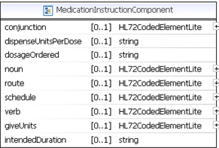

Figure : Medication Instructions Structure

The following is an example of mapping the object into a single Java String:

* {noun} {dosageOrdered} Qty: {giveUnits} for {intendedDuration}

The variables in the brackets show how the ‘MedicationInstructions’ component’s properties can be used to construct the Java String.

Note: This is a “best guess” possibility documented to facilitate the transformation. As of this writing, a Subject Matter Expert (SME) has not signed off on this mapping.

## Date Formats

In order to facilitate transformation, the date formats being used by the two systems must be specific and unambiguous. The format string adheres to Java’s ‘SimpleDateFormat’ specification.

Refer to: <https://docs.oracle.com/javase/7/docs/api/java/text/SimpleDateFormat.html>

The following table displays the date formats and provides an example.

Table : Date Formats

| SYSTEM | FORMAT | EXAMPLE | “normal” human-readable format |
| --- | --- | --- | --- |
| HL7 | yyyyMMdd.HHmmss | 20150517.000000 | 05/17/2015 or  May 17th, 2015 (midnight) |
| HL7 | yyyyMMdd | 20161110 | 11/10/2016 or  November 10th, 2016 |
| HDR/CDS | yyyyMMddHHmmssZ | 20140418183901-0700 | 04/18/2014 18:39:01-0700 or  April 18th, 2014 at 6:39:01pm MST (mountain standard time) |

# HL7 Messages

The following table displays the HL7 messages that flow in and out of the VA eMI.

Table : HL7 Message Flow

| Request | Response | Description | Service Reference |
| --- | --- | --- | --- |
| QBP^Q13 | RTB^K13 | Query HDR for patient medication re |  |
| SOAP readClinicalData | SOAP  OutpatientMedicationPromise | eMI transforms the QBP^Q13 request into the SOAP request to the HDR |  |
| RDS^O13 | RRD^O14 | Pharmacy/Treatment Dispense Message |  |

## QBP^Q13

The VA eMI ESB will handle QBP-Q13 HL7 query requests to the HDR/CDS to retrieve a patient’s list of active prescriptions. The response will be in a XML SOAP format which will be transformed into an HL7 v2.x RTB-K13 message with tabular data containing aggregated, active prescription information in the remote VistAs.

The following is a sample of the QBP^Q13 request.

Sample QBP^Q13 Request

**MSH**|^~\&|PSO VISTA PHARM|2101|PSO MIRTH PHARM|36500|20140102125951-0500||QBP^Q13|301|T|2.5.1|||NE|AL|USA

**QPD**|Q13^Active Prescriptions^HL70471|512123456

**PID**|||1666000286V397907^^^USVHA^NI^200M~100232^^^USVHA^PI^500~100445^^^USVHA^PI^612~100232^^^USVHA^PI^2204~100232^^^USVHA^PI^2202

RCP|I

The Patient Identification (PID) segment should have the following structure:

* ICN^^^USVHA^NI^SITE NUMBER

The following table lists the data elements and their descriptions found in the PID segment.

Table : PID Segment Data Elements and Descriptions

| NAME | DESCRIPTION |
| --- | --- |
| ICN | Integration Control Number |
| USVHA | United States Veteran Health Administration |
| NI | National Identifier |
| SITE NUMBER | Site number of the originating VistA system |

## RTB^K13

The following is a sample of the RTB^K13 response message.

Sample RTB^K13 Request

MSH|^~\&|ZJTH MIRTH PHARM|36500|ZJTH VISTA PHARM|2101|20140109155138.281-0500||ACK^Q13^ACK|19|T|2.5.1

MSA|AA|50022643

QAK|512123456|OK|Q13^Active Prescriptions^HL70471|2

RDF|12|Site Number~Rx Number~Drug Name~Quantity~Refills~Days Supply~Expiration Date~Issue Date~Stop Date~Last Fill Date~Sig~Detail~Status~VA Product ID

RDT|2302|501109|NAPROXEN 250MG TAB|60|11|30|20150517.000000|20140516.000000|20150517.000000|20140516.000000|TAKE ONE TABLET BY MOUTH TWICE A DAY|NAPROXEN 250MG TAB Qty: 60 for 30 days|Active|399279439

RDT|2302|501110|RANITIDINE HCL 25MG EFFER TAB|60|6|30|20150517.000000|20140516.000000|20150517.000000|20140516.000000|DISSOLVE 1 MOUTH TWICE A DAY|RANITIDINE HCL 25MG EFFER TAB Qty: 60 for 30 days|Active|499220379

## RDS^O13

The ‘RDS^O13’ is a pass through message that requires no transformation by the eMI. The following are sample refill and partial refill ‘RDS^O13’ messages.

Sample RDS^O13 Refill Request

**MSH**|^~\&|PSO VISTA PHARM|2201|PSO ESB PHARM|36500|20140415110833-0500||RDS^O13|50024242|T|2.5.1|||NE|AL|USA

**PID**|||1666000286V397907^^^USVHA^NI^200M~100232^^^USVHA^PI^2202

**ORC**|RF|500974^2202|||||||20140415|1^PROGRAMMER^ONE|||^^^500|6655544

**RXO**||||||||W^^^2201

Sample RDS^O13 Partial Fill Request

**MSH**|^~\&|PSO VISTA PHARM|2201|PSO ESB PHARM|36500|20140716081903-0500||RDS^O13|50030627|T|2.5.1|||NE|AL|USA

**PID**|||1111000440V046182^^^USVHA^NI^200M~101016^^^USVHA^PI^2202

**ORC**|PF|501145^2202|||||||20140710|10000000225^TERRELL^GAIL|||^^^500|502-233-2355

**RXO**|1|10||||||W^^^500|||10

**NTE**|1|L|test

## RRD^O14

The ‘RRD^O14’ message is the response to the ‘RDS^O13’ message. The following are sample refill and partial refill ‘RDS^O14’ messages.

Sample RRD^O14 Refill Response

MSH|^~\&|PSO ESB PHARM|36500|PSO VISTA PHARM|2302|20140723091250.151-0400||ACK^O13^ACK|12173|T|2.5.1

MSA|AR|50024459

PID|||1111000449V272697^^^USVHA^NI^200M~101044^^^USVHA^PI^2303

ORC|UF|501109^2303|||||||20140723|10000000225^TERRELL^GAIL|||^^^500|490-444-5555

Sample RRD^O14 Partial Fill Response

**MSH**|^~\&|PSO ESB PHARM|36500|PSO VISTA PHARM|2201|20140716081939.298-0400||ACK^O13^ACK|10412|T|2.5.1

**MSA**|AA|50030627

**NTE**|1||Partial complete for RX #501145.

**PID**|||1111000440V046182^^^USVHA^NI^200M~101016^^^USVHA^PI^2202

**ORC**|OF|501145^2202|||||||20140710|10000000225^TERRELL^GAIL|||^^^500|502-233-2355

**RXD**|1|^NAPROXEN 125MG/5ML SUSP^NDC|20140710000000-0400|10|||404366::1|||^RADIOLOGIST^ONE^^^^^^^^^^^^^2&VEHU SITE^^^20140717162300-0400||10